Overview:

The Supermarket CRM Tool facilitates seamless billing for retail and wholesale customers, utilizing pricebook entries. During the billing process, customer mobile numbers are collected for data collection purposes. The system offers a Shop Pulse Point for customers to redeem points and receive discounts on their total bill. Existing customers can quickly retrieve their information by entering their mobile number. Post-billing, the system automatically updates product stock, triggering notifications to the business owner when quantities fall below a threshold. Additionally, a one-click feature enables grouping of products by suppliers, prompting email notifications for reorder requests. The tool also aids in employee attendance tracking and simplifies product price modification through automated flows.

Data Model:

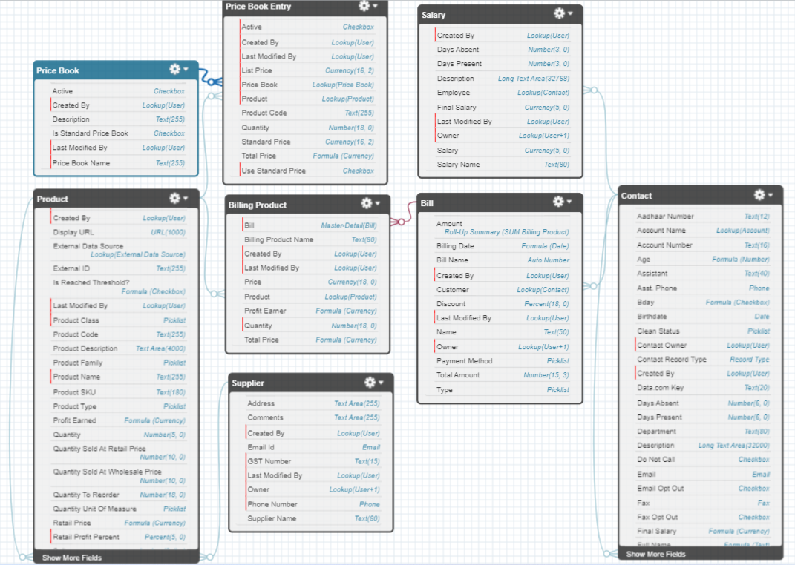

User Manual:  
  
First let’s see how the products and their pricing can be added.

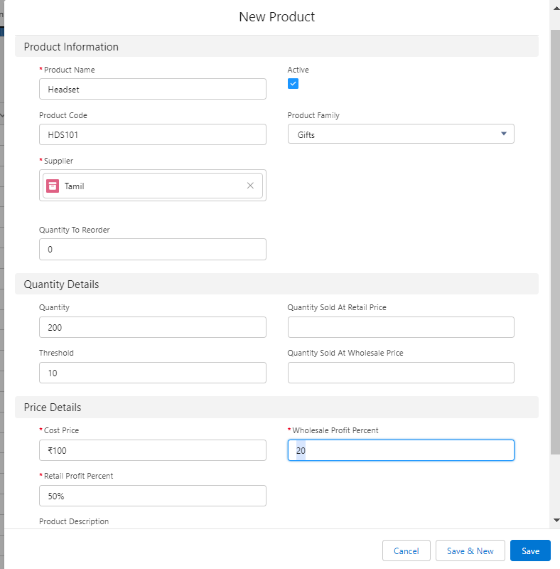  
  
**Adding a New Product**

Follow these steps to add a new product to the system:

**Navigate to the Product Tab:**

Click on the "Product" tab in the Salesforce interface.

**Initiate Product Creation:**

Click on the "New" button to start the product creation process.

Complete Product Information:

**Fill in the following details:**

**Product Name:** Enter a unique name for the product.

**Product Code:** Specify a code to uniquely identify the product.

**Product Family:** Categorize the product family (used for dashboard analytics).

**Supplier Field:** Assign the supplier for reordering purposes.

**Threshold Field:** Set the threshold quantity to trigger alert notifications.

**Quantity Sold at Retail Price:** Automatically updated upon retail billing.

**Quantity Sold at Wholesale Price:** Automatically updated upon wholesale billing.

**Price Detail Section:**

In the price detail section, enter the following information:

**Cost Price:** Specify the cost price of the product.

**Wholesale Profit Percentage:** Enter the profit percentage expected for wholesale sales.

**Retail Profit Percentage:** Enter the profit percentage expected for retail sales.

**Automated Pricebook Entry Creation:**

Two flows, namely "Product Record Trigger: Update Price Book Entry" and "Product Record Trigger: Create Price Book Entry," dynamically create pricebook entries based on the provided profit percentages.

**Flow-Based Pricebook Entry Update:**

Upon updating the profit percentages, the associated flows automatically adjust the prices in the pricebook entries, ensuring real-time synchronization.

These steps guide you through the seamless addition of a new product, including important details and the automated creation of pricebook entries for both retail and wholesale pricing.

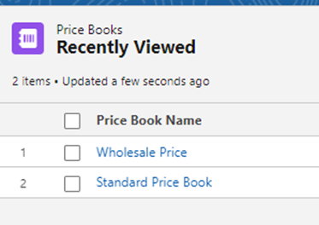Standard Price Book is treated as retail price book

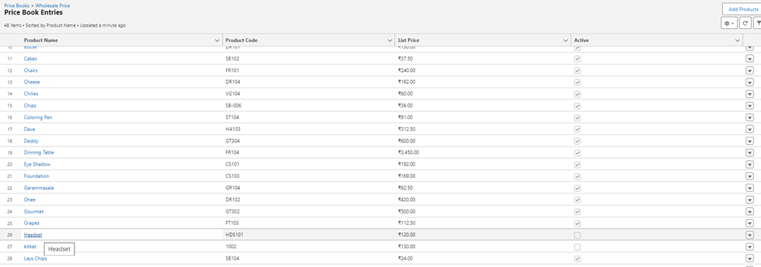

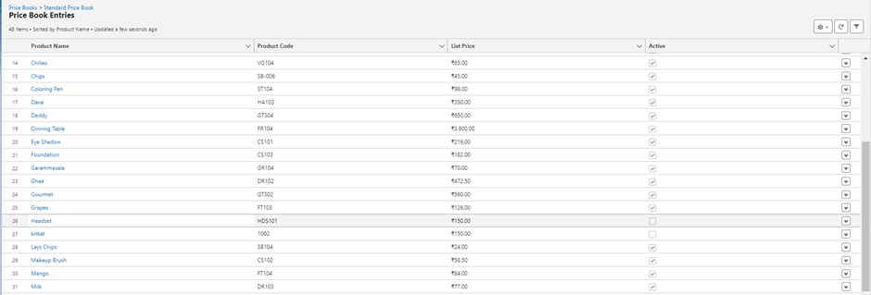

**Automated Pricebook Entry Management**

The system automates the creation of price book entries in the relevant pricebooks, with the unit price dynamically calculated based on the specified profit percentages during the product creation process. Any modifications made to these profit percentages are instantaneously reflected in the associated pricebook entries.

This automation streamlines the pricing process, alleviating the need for manual adjustments in both pricebooks whenever product prices change. It provides a hassle-free solution for businesses, ensuring accurate and synchronized pricing across retail and wholesale channels.

—------------------------------------------------------------------------------------------------------------------------------------------

**Billing Process**

**Product Selection:**

Navigate to the "Bill" tab and start the billing process.

Choose the customer type (retail or wholesale).

**Product Selection and Modification:**

Utilize the search option in the pricebook entry table to select products efficiently.

Modify product quantities as needed during the billing process.

Delete mistakenly added products using the delete button provided for each row.

**Total Amount Calculation:**

Display the total amount at the bottom, calculated based on unit prices and purchased quantities.

**Customer Data Section:**

After selecting products, proceed to the customer data section.

Retrieve the customer's mobile number.

If the customer is a shop member, fetch their Shop Pulse Points for potential discounts.

If not a member, initiate the creation of a membership account through a flow.

**Payment Method Selection:**

Choose the payment method opted by the customer.

**Complete Billing:**

Click "Bill" to confirm selected products and move to the next step.

On completing the billing process, creating Bill records at the backend.

**Automated Backend Processes:**

Bill records are generated with billing products as child records, linked to the customer, billing amount, payment method, and retail/wholesale details.

These records provide valuable insights into customer behavior, high-priority customers, payment trends, daily sales, and daily profits.

Updates are made asynchronously to fields such as total retail and wholesale products sold and product stock quantities, ensuring seamless automation without waiting.

This structured approach guides billing staff through a user-friendly process while capturing essential data for business insights and analysis.

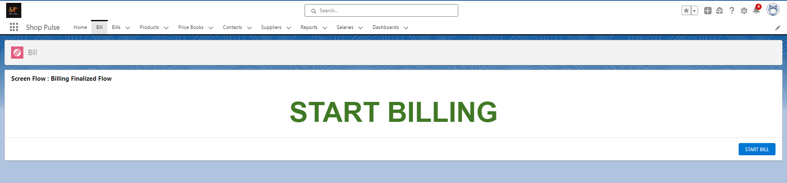

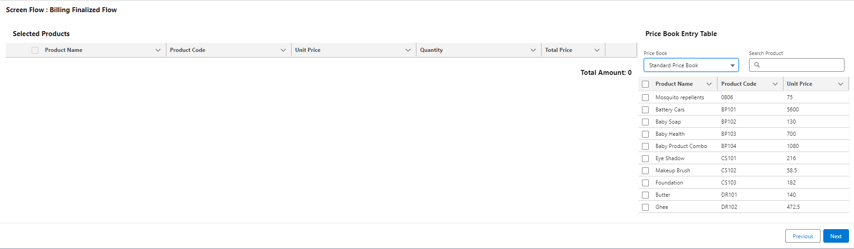

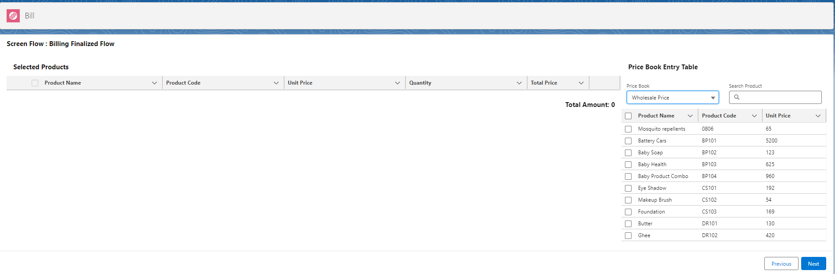

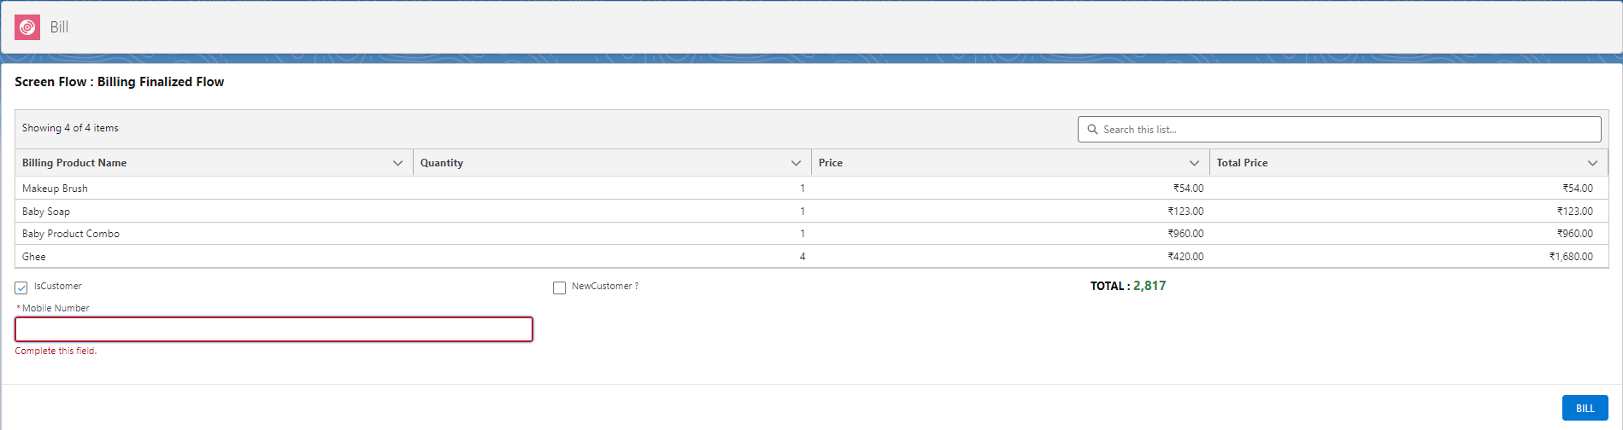

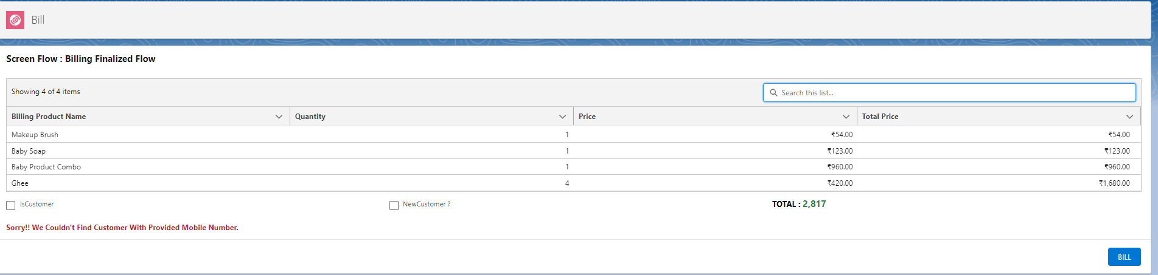

Upon entering wrong mobile number or there is no membership account exist with the given phone number we display the error message.

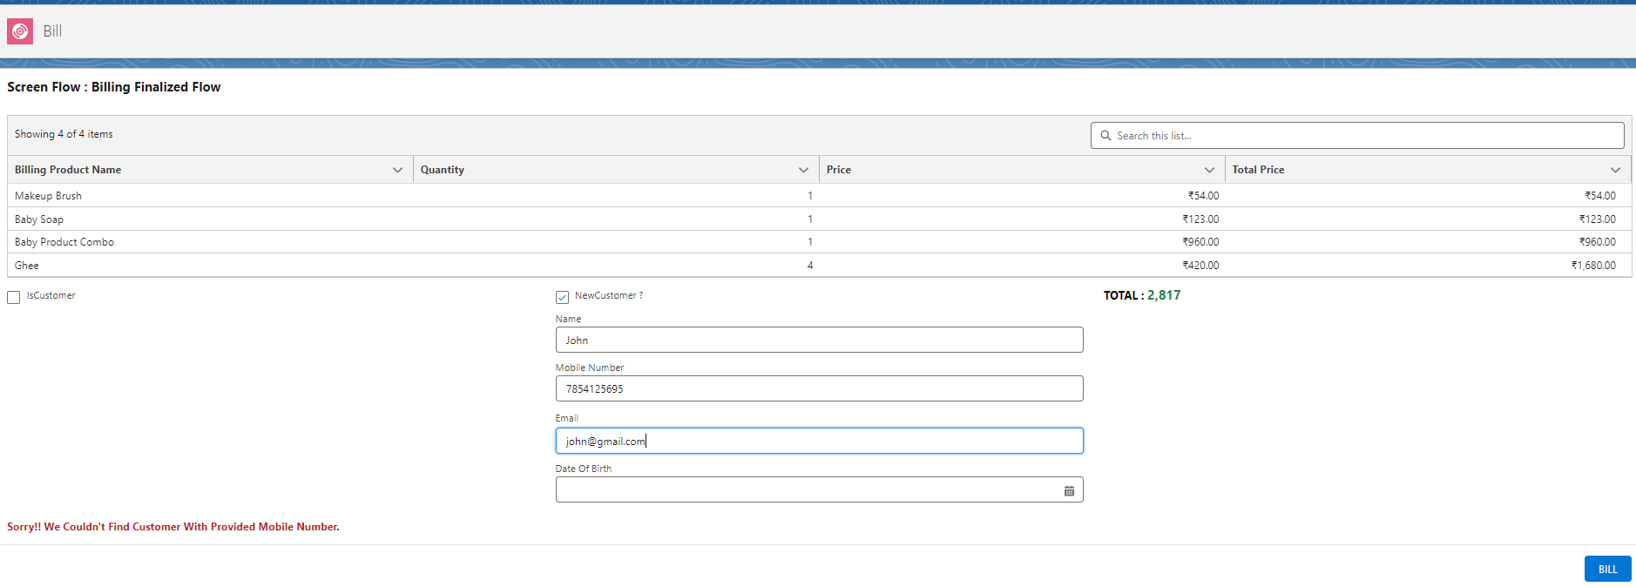  
Create new membership account on flow!

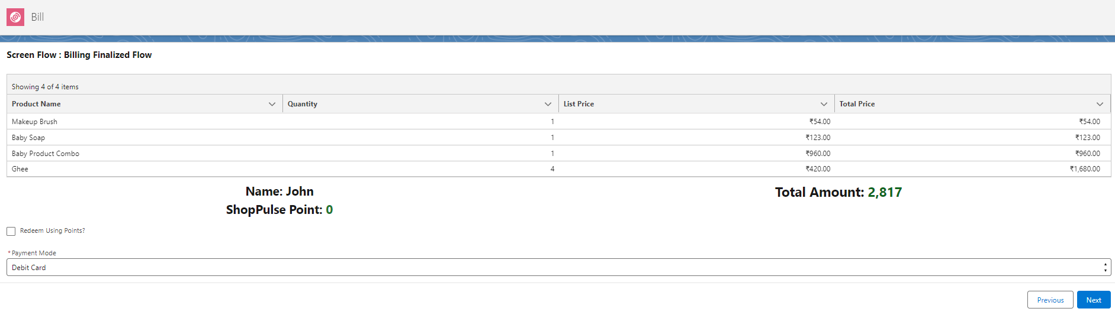  
As John here is new member he have 0 shop pulse points. Select the payment method and click next.

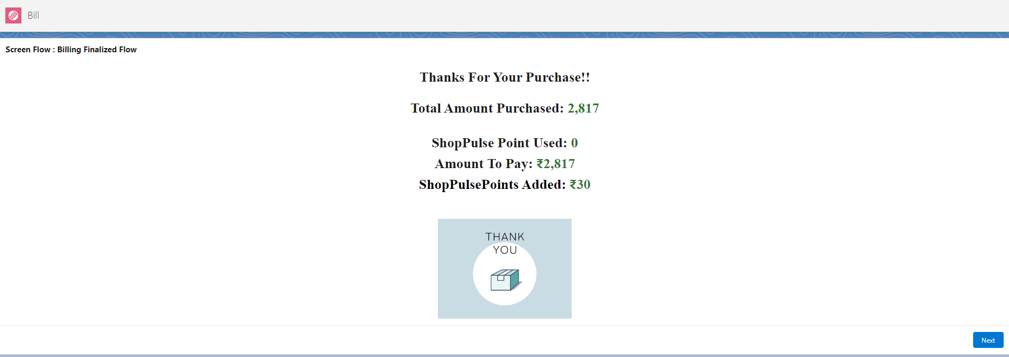

We are adding 30 shop pulse points to his account. Which he can use it on his next purchase!

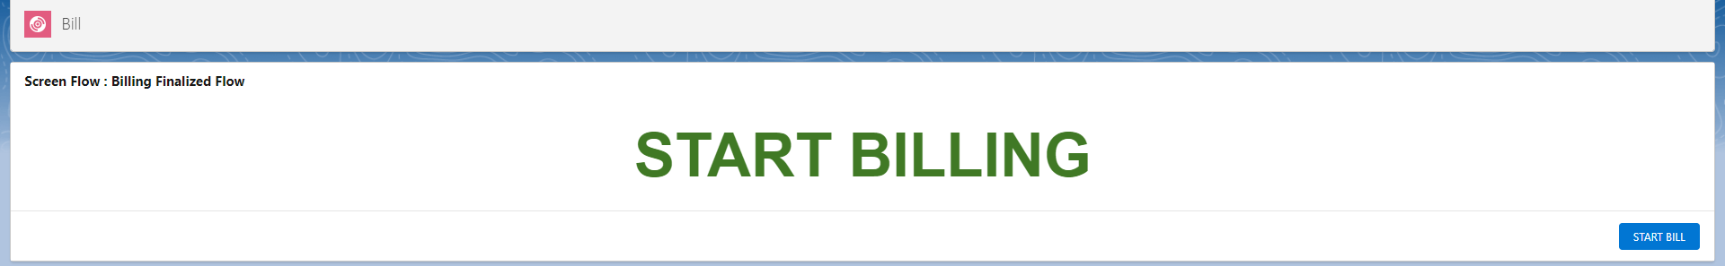  
On clicking next we are back to the first page.

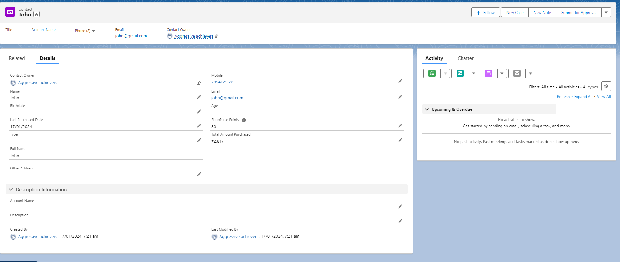  
  
Here you can see john contact record was created with the important fields to track the customer’s activity with our business.

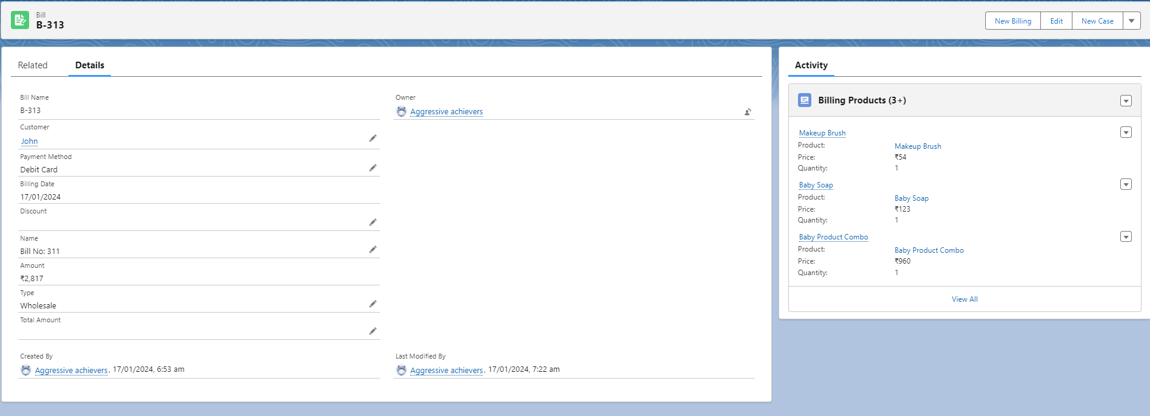

Also a bill record was created with the billing products as its child.

Now let’s bill again with the John Account as customer and Headset Product as purchased product.

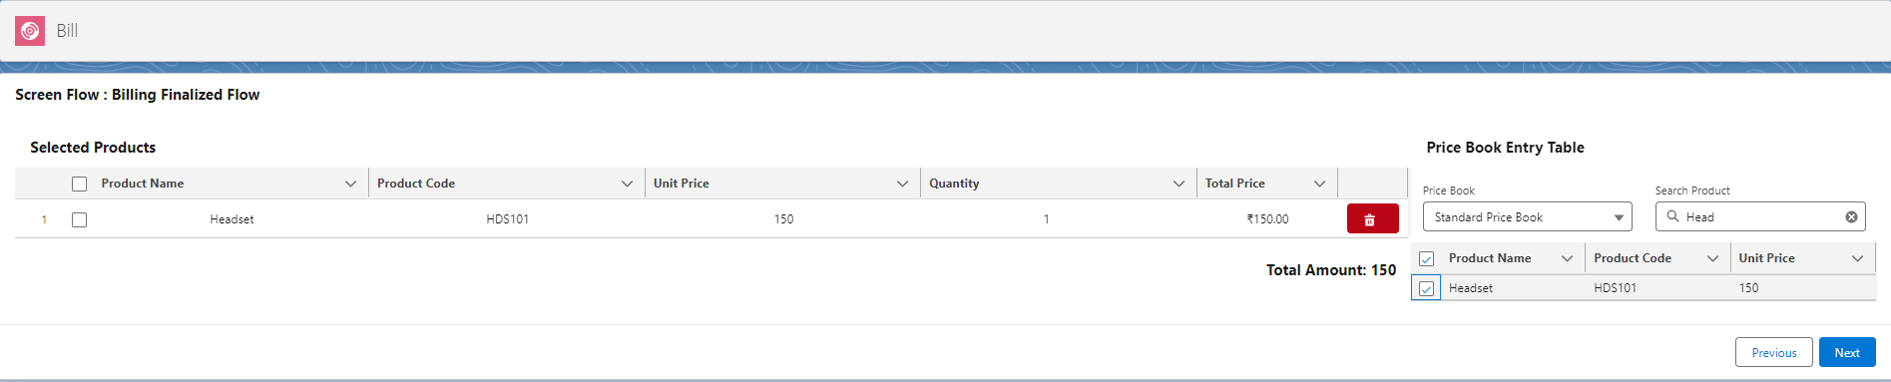

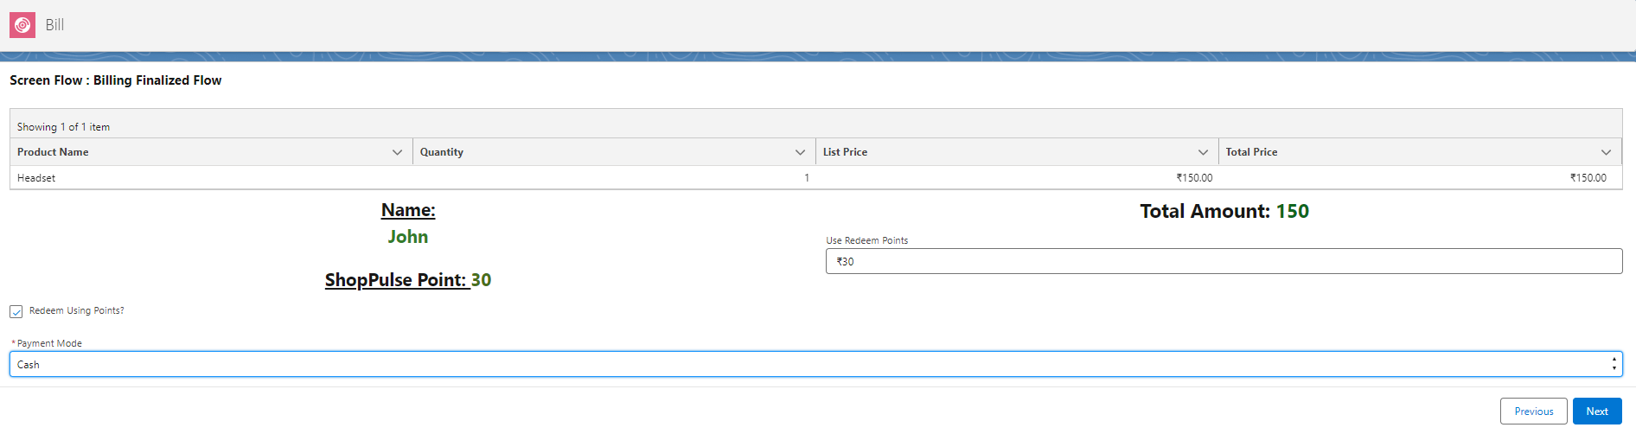

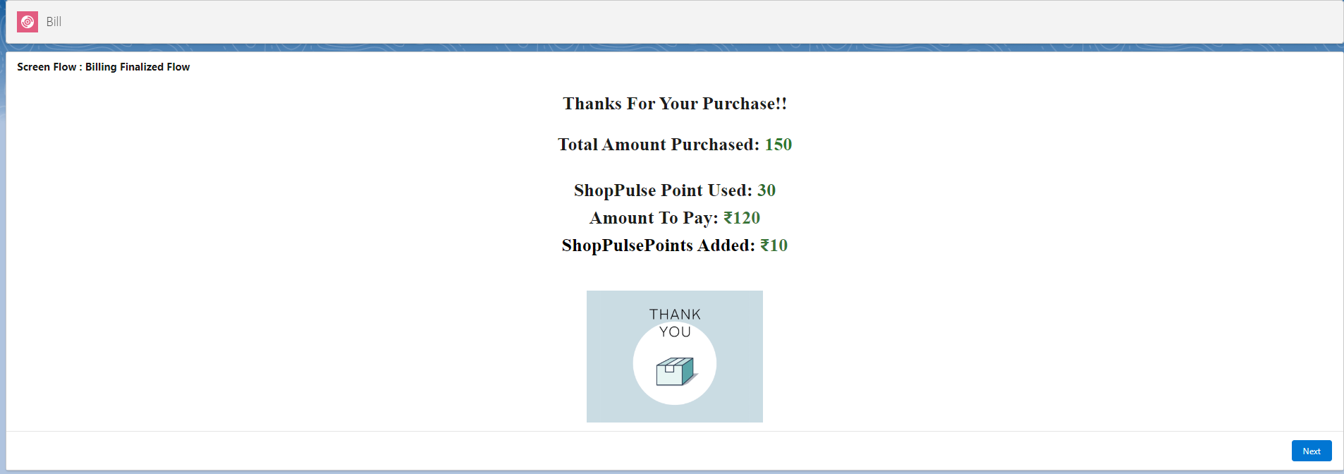

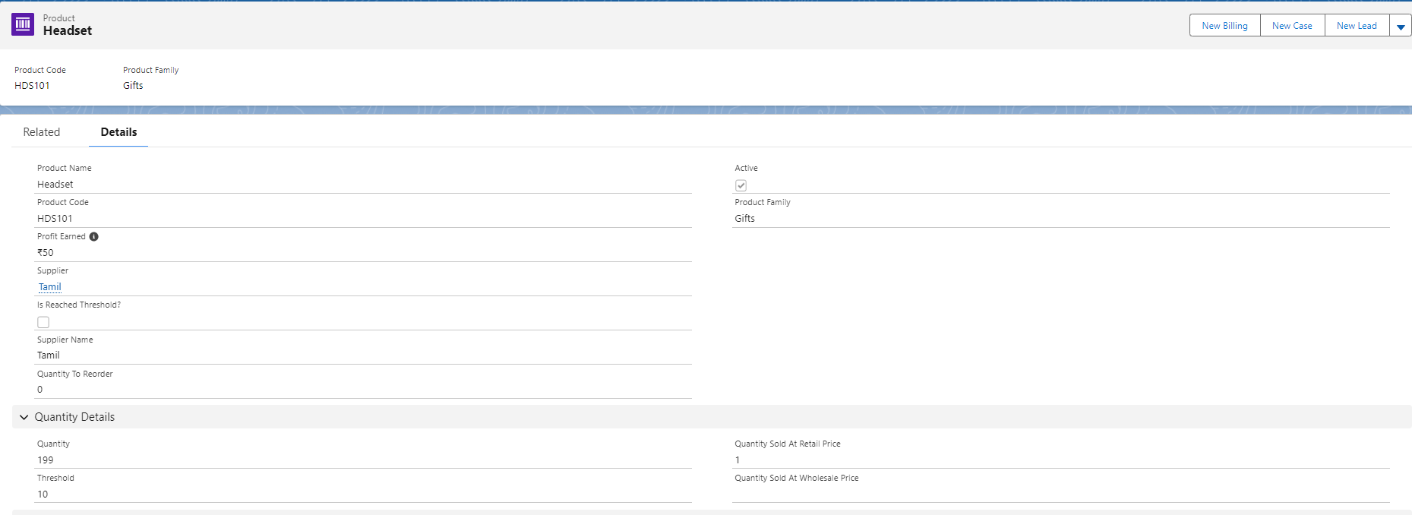

Here you can see that Quantity Sold At Retail, Quantity fields were updated automatically.

—---------------------------------------------------------------------------------------------------------------------------------------

**3) Products Reorder Process**

**Navigate to Home Screen:**

From the Home screen, access the products reorder section.

**Threshold Notifications:**

At the bottom of the Home screen, view products below the threshold quantity, grouped by suppliers.

**Add Additional Products:**

Add extra products to reorder from the list available on the right side datatable.

**Automatic Inclusion:**

On selecting products, they are automatically added to the list of products to reorder.

**Supplier Grouping:**

If the supplier is already present in the grouped reorder, products are added to the existing section.

If the supplier is new, a new section is created for the supplier.

**Modify Quantity:**

Adjust the quantity to reorder as needed.

**Initiate Reorder:**

Click the "Reorder" button to confirm and initiate the reorder process.

**Email Notifications:**

All suppliers receive an email containing information about the products to reorder.

This streamlined process provides an efficient way to manage products below the threshold, add new items, and communicate reorder information to suppliers seamlessly.

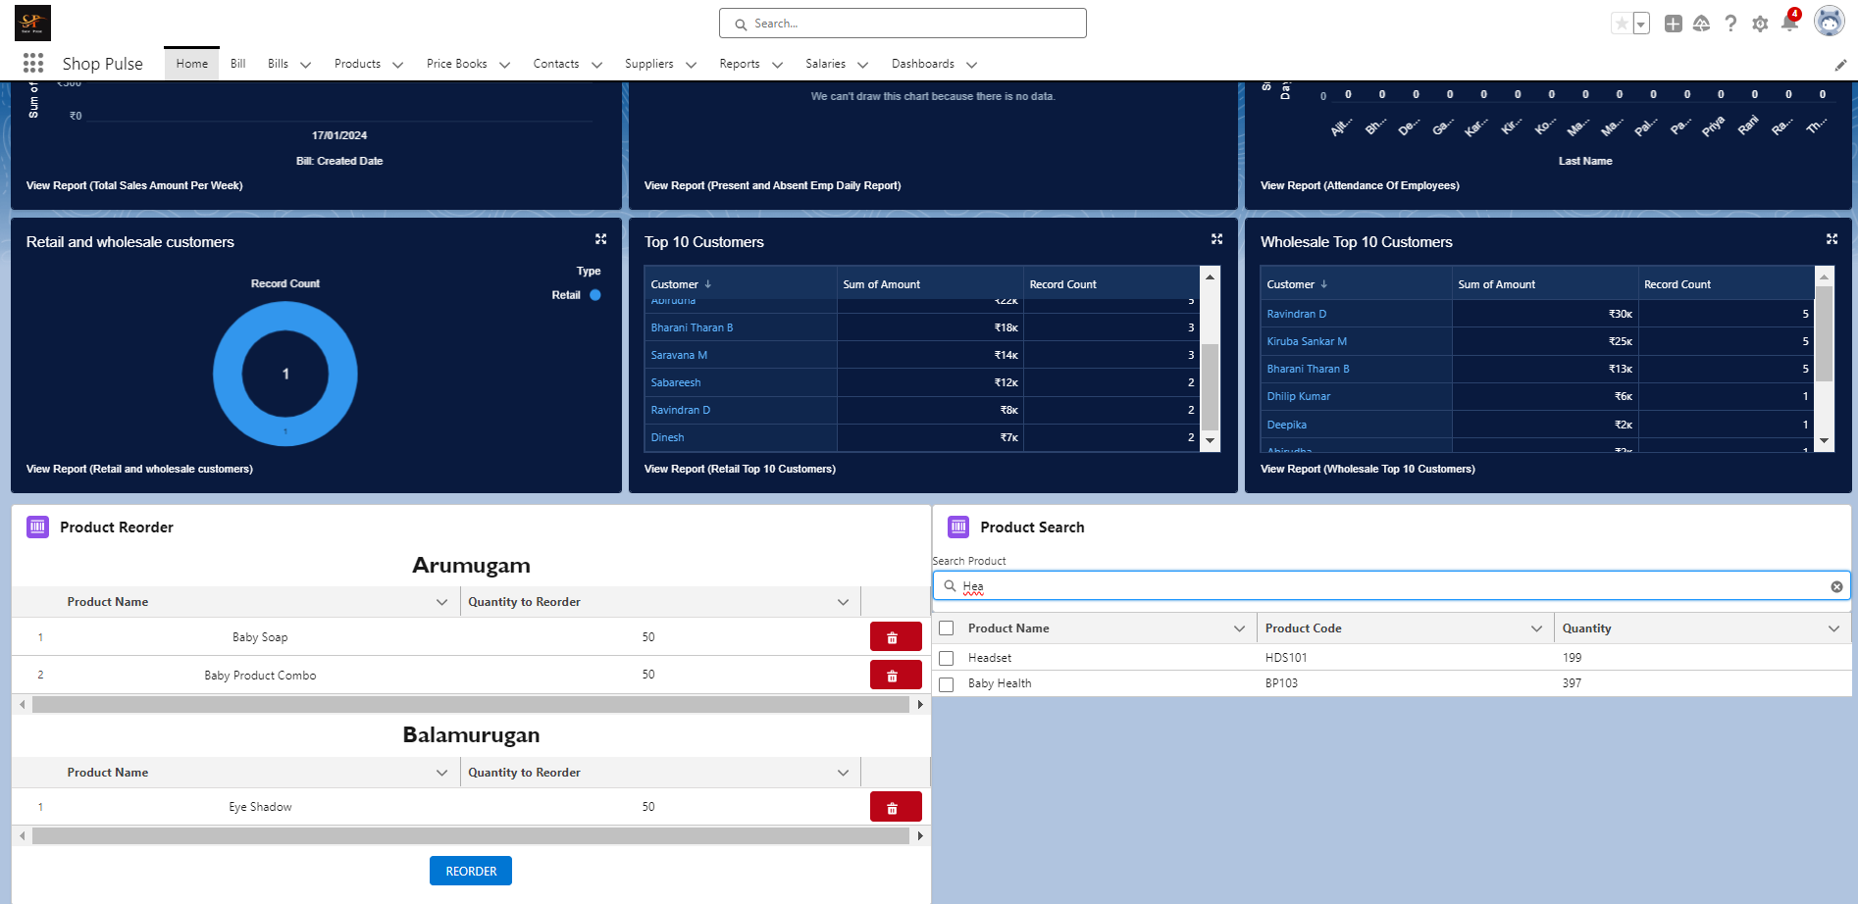

Here you can see on selecting Headset product new section is created for supplier “Tamil” whose email id is mine.

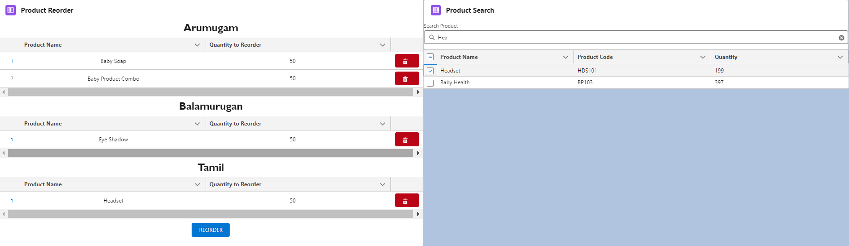

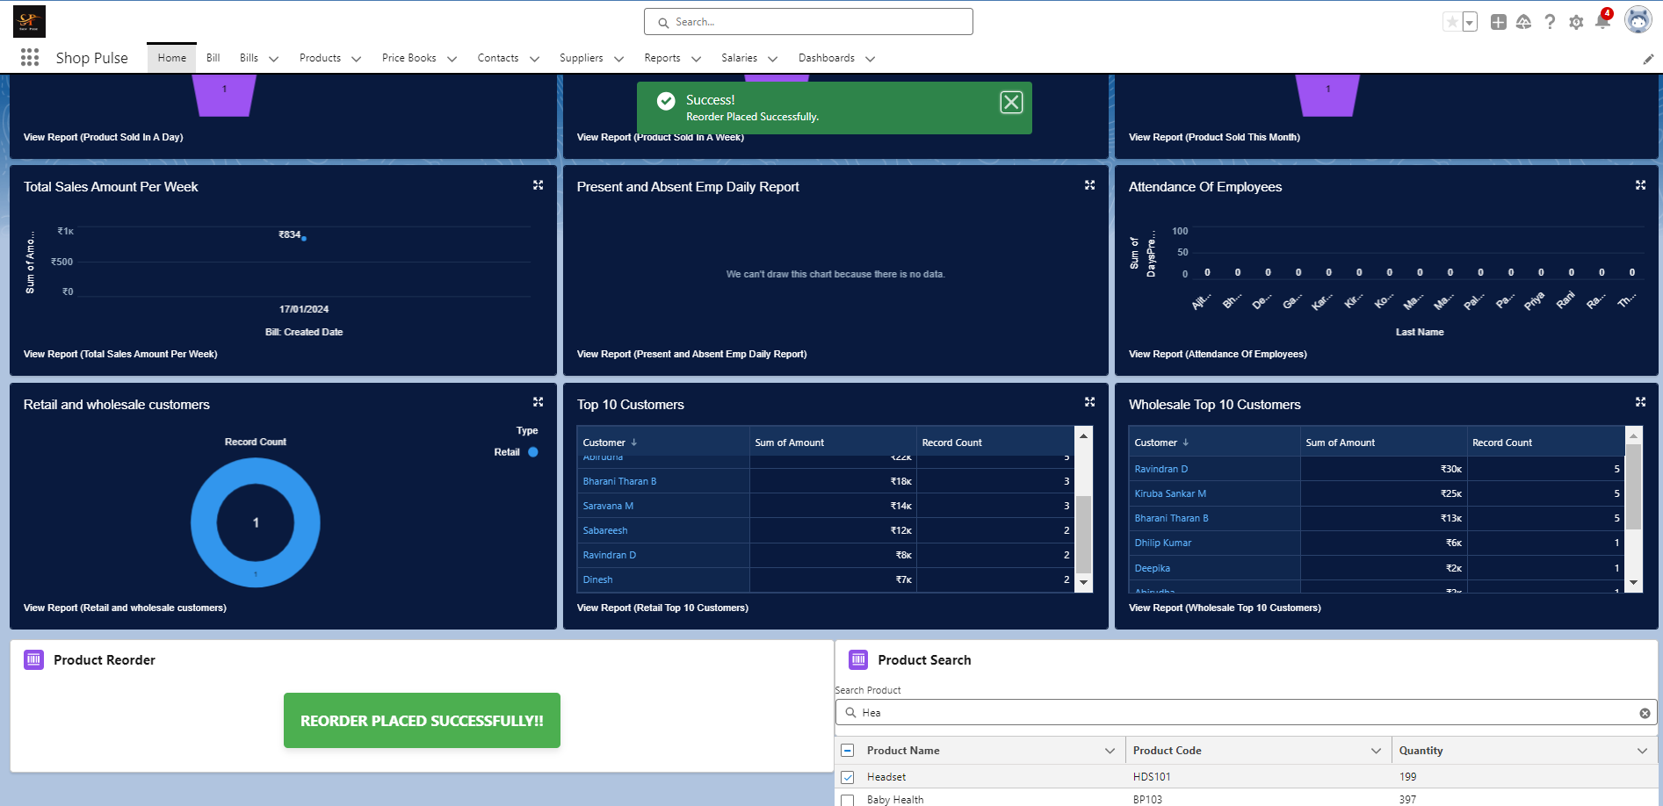

On clicking reorder you will see toast message and the component shows REORDER PLACED SUCCESSFULLY.

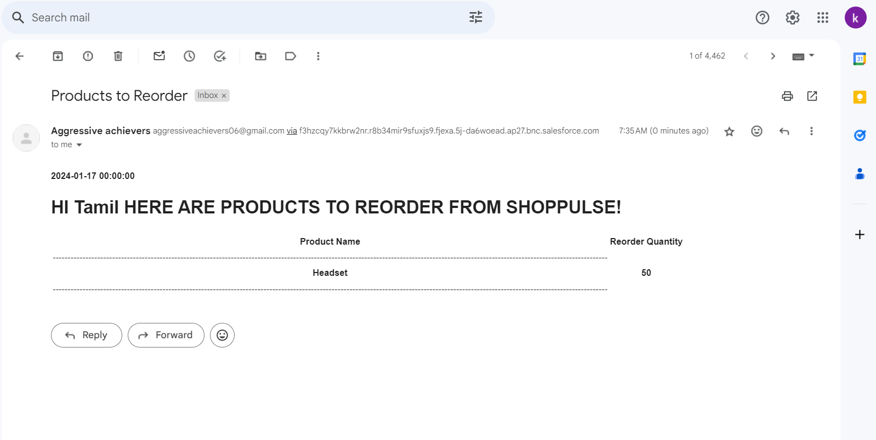

And I have received an email regarding the products to reorder!!!

—------------------------------------------------------------------------------------------------------------------------------------------

**Employee Attendance Management**

**Navigate to the Contact Tab:**

Access the "Contact" tab in the Salesforce interface.

**Select Employees List View:**

Choose the "Employees" list view to display the list of employees.

**Mark Attendance:**

Select all employees by clicking the checkbox at the top for ease.

Deselect employees who were absent.

**Register Attendance:**

Click the "Register Attendance" list view button to confirm attendance.

**Automated Backend Processes:**

A backend flow runs, updating fields such as "Days Present," "Days Absent," and the "Description" field in the contact object.

These details are crucial for salary calculation for each employee.

**Monthly Salary Tracking:**

A scheduled trigger flow runs at the start of every month.

It creates a record in the salary object, keeping track of salaries paid to employees.

**Reset Attendance Details:**

After salary processing, the "Days Present," "Days Absent," and "Description" fields in the contact object are reset to their initial values using the Employee Record Type.

This systematic approach simplifies employee attendance management, ensures accurate salary calculations, and maintains a record of salaries paid to employees over time.

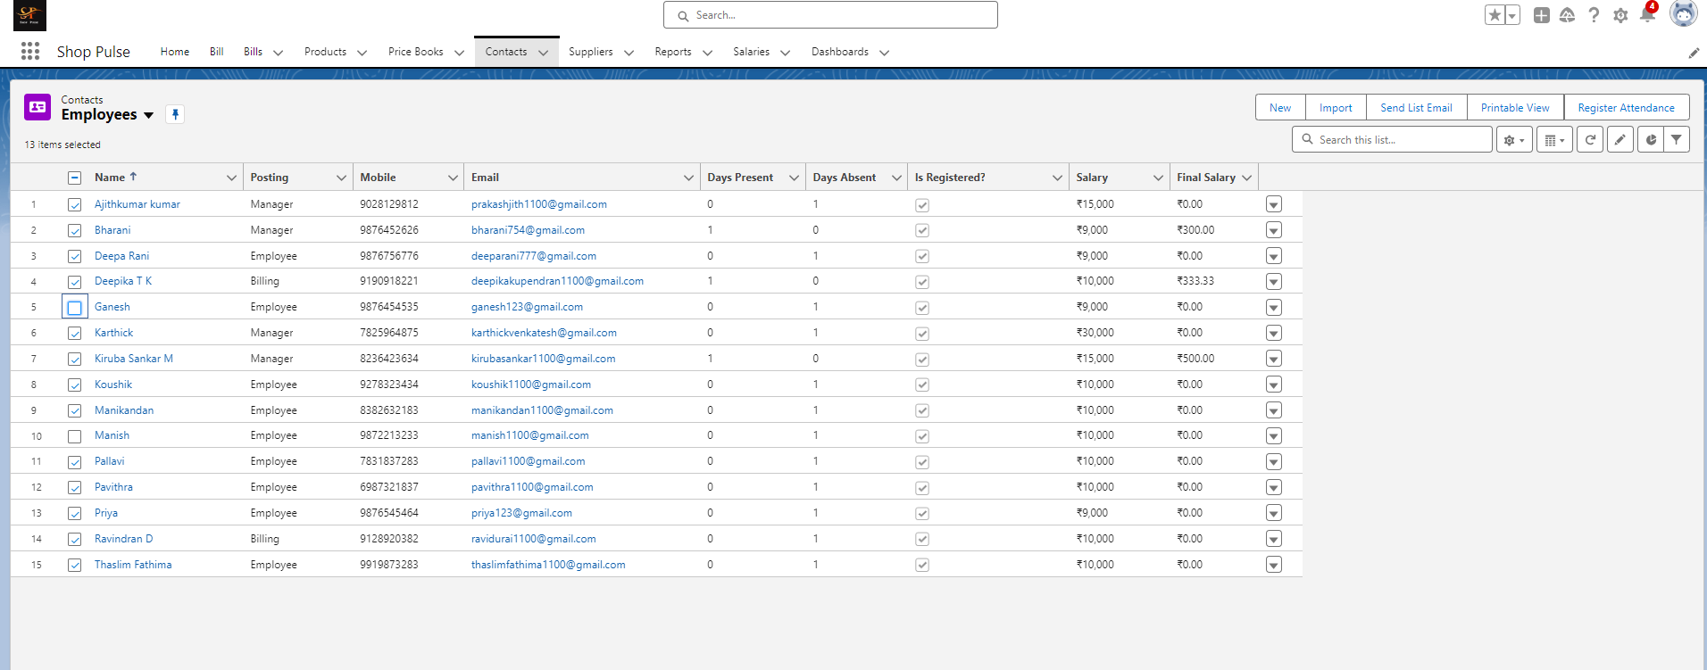

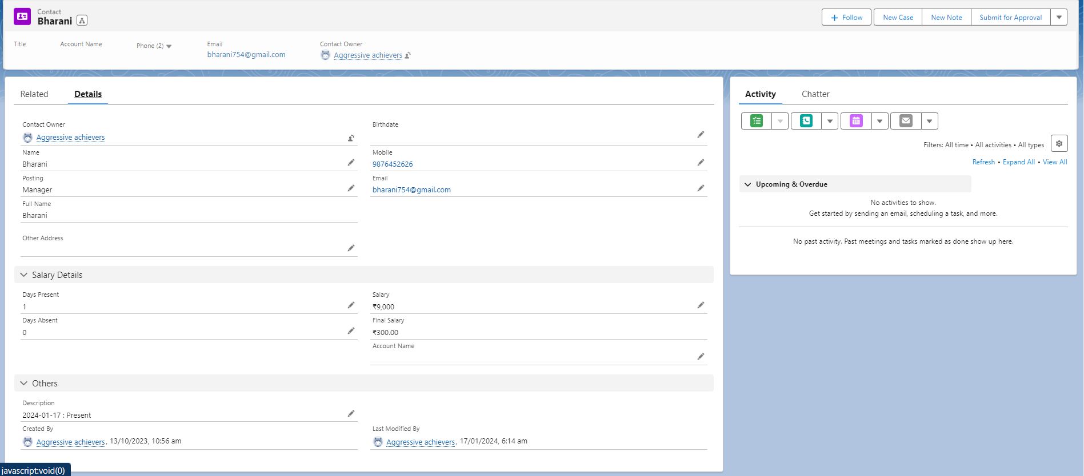  
  
Here you can notice that Final Salary is auto calculated based on number of days present and salary field. And in Description field you can see how the information were stored for future reference.

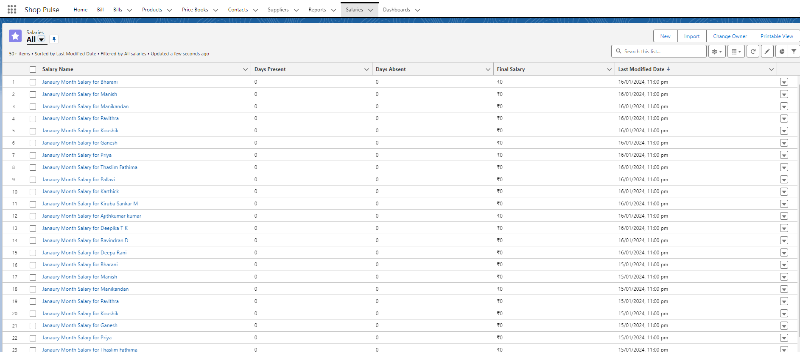  
  
This is how salary records will be created with the nomenclature followed for easy reference.

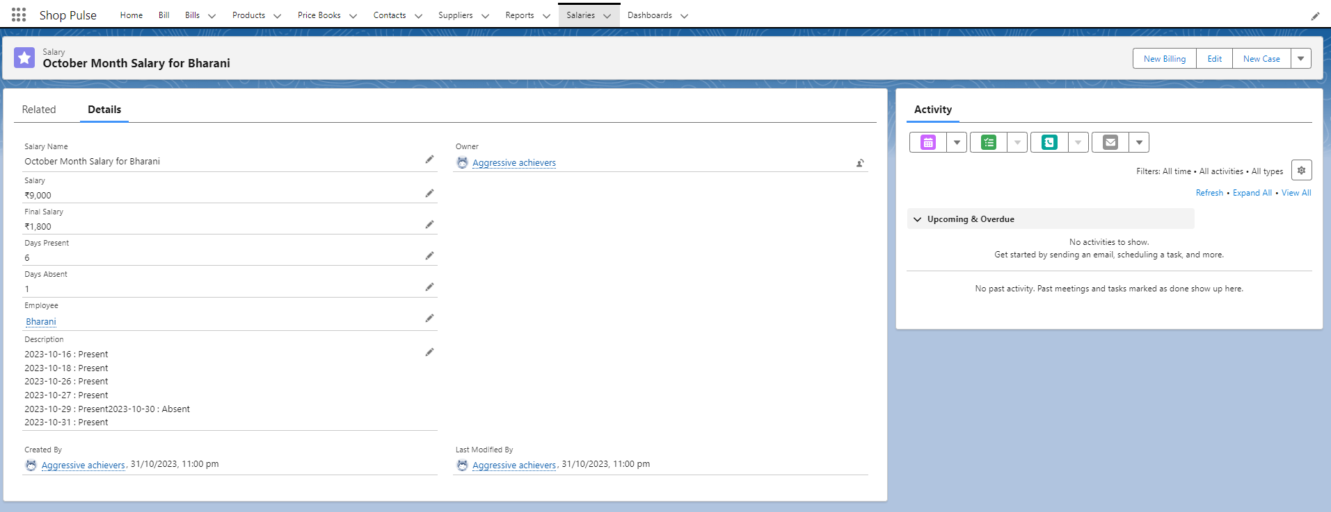

This detail page provides crucial information related to the salary record, which is transferred from the employee record. The information includes details such as "Employee Name," "Days Present," "Days Absent," and additional fields necessary for accurate salary calculation.

5) Reports and Dashboards:

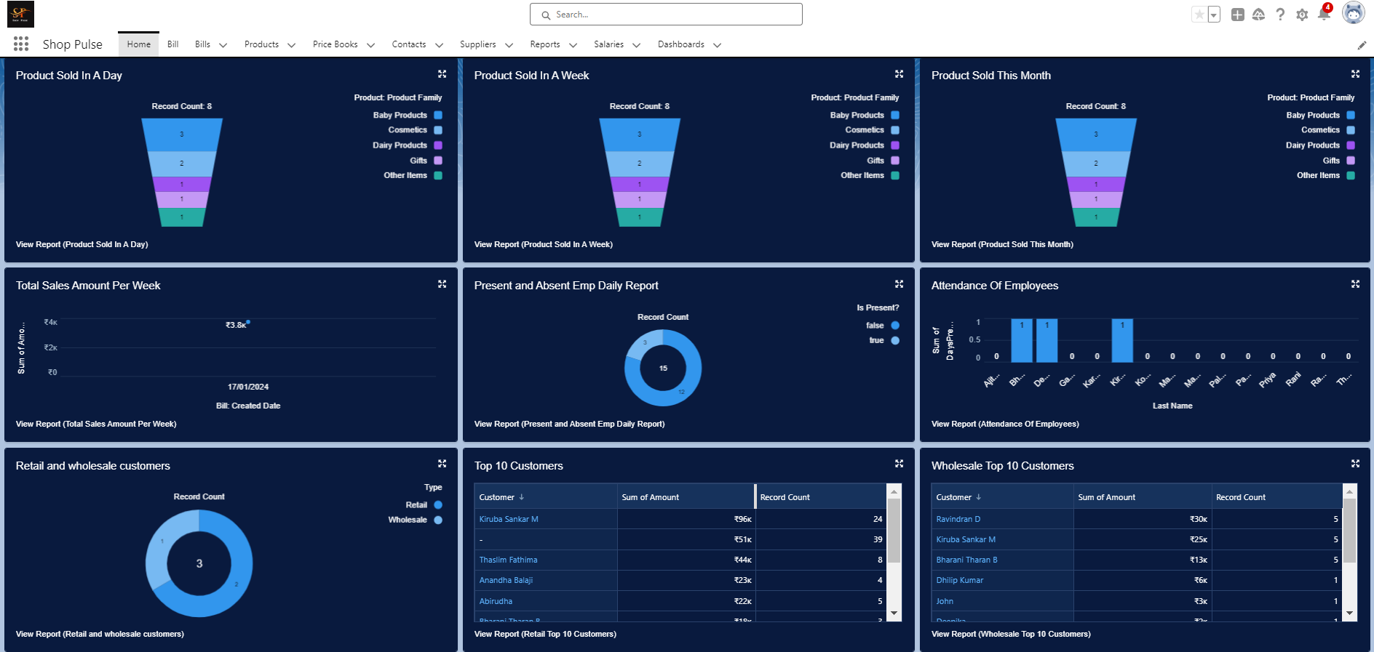

**Business Insights Dashboards**

Here, you will find a set of crucial dashboards designed to provide insightful visual representations for effective business decision-making:

**Product Sales Overview:**

**Products Sold in a Day:** Visualizes the daily sales of products, offering insights into which products are popular on a daily basis.

**Products Sold in a Week:** Provides a weekly overview of product sales, aiding in identifying trends and patterns.

**Sales Performance Dashboards:**

**Products Sold in a Month:** Offers a comprehensive monthly view of product sales, helping businesses understand long-term product performance for strategic planning.

**Retail and Wholesale Customers:** Segregates sales data between retail and wholesale customers, allowing for targeted marketing and inventory management.

**Customer Engagement Dashboards:**

**Top 10 Retail Customers:** Identifies and rewards the top 10 retail customers, fostering strong customer relationships and loyalty.

**Top 10 Wholesale Customers:** Recognizes and appreciates the top 10 wholesale customers, enhancing business-client relationships.

**Operational Tracking Dashboard:**

**Total Sales Day Wise (Past One Week):** Tracks daily sales for the past week, providing a quick snapshot of the business's performance.

**Employee Attendance Dashboard:**

**Attendance of Employees:** Offers a visual representation of employee attendance, facilitating easy monitoring and management of workforce engagement.

These dashboards collectively offer a comprehensive overview of product sales, customer engagement, operational performance, and employee attendance. They serve as powerful tools for businesses to make informed decisions, enhance customer relationships, and optimize day-to-day operations.

—------------------------------------------------------------------------------------------------------------------------------

**Birthday Wishes and Shop Pulse Points**

As part of our customer relationship-building initiative, we have implemented a scheduled trigger flow to automate the process of sending birthday wishes to our valued customers. This flow operates on a schedule, identifying customers whose birthdays are on the current date.

**Key Features:**

**Birthday Wishes via Email:**

On the customer's birthday, an automated email is sent to extend warm birthday wishes, enhancing the personal connection with our customers.

**Shop Pulse Points Addition:**

If the customer is a member of our shop, the flow also adds shop pulse points to their account.

These additional shop pulse points serve as a token of appreciation, providing an extra benefit for our loyal customers.

This automated process ensures that our customers feel valued and appreciated on their special day, contributing to the establishment of a robust and positive relationship between the business and its customers.

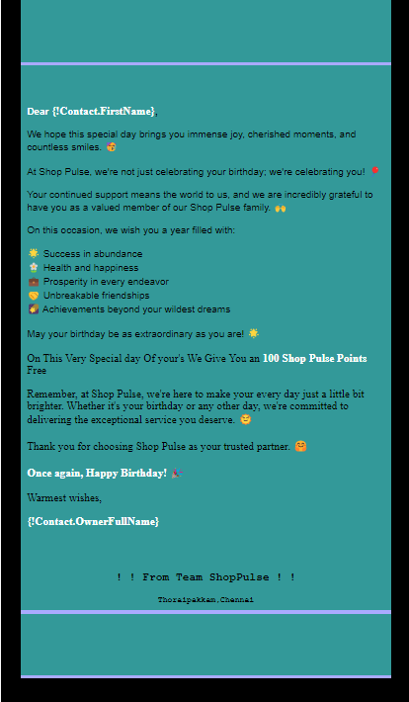

**Conclusion:**

In conclusion, this comprehensive CRM tool for supermarkets encapsulates efficient product management, streamlined billing, employee attendance tracking, and insightful dashboards, fostering stronger customer relationships through personalized birthday wishes and shop pulse point rewards, ultimately empowering the business with operational excellence and strategic decision-making capabilities.